Experiment No. 1
- Title: 1D Bar Element – Structural Linear Analysis
- Aim: To perform structural linear analysis of a one-dimensional (1D) stepped bar element using the finite element method in order to determine nodal displacements, stresses, and strains under applied axial load and to understand the basic formulation and behavior of 1D elements.
- Problem Statement:
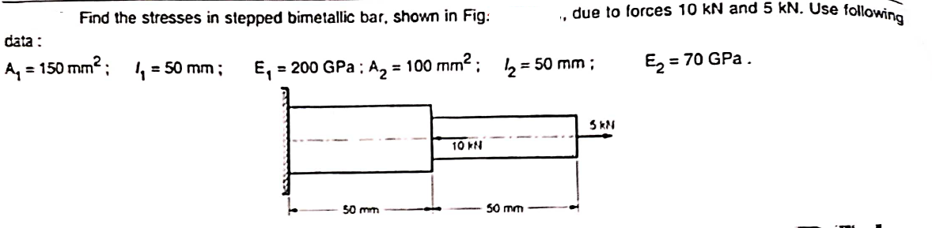
- Solve given problem using basic steps of FEA

- Steps In Ansys to solve problems
Preprocessing
- ANSYS Main Menu → Preferences → Select STRUCTURAL.
- Element Type → Add/Edit/Delete → Add → Link → Select 3D Finite Strain 180 → OK → Close.
- Material Properties → Material Models → Structural → Linear → Elastic → Isotropic → EX →
Enter 2×10⁵ → PRXY → 0.3 → OK.
- Material → New Model → Structural → Linear → Elastic → Isotropic → EX → Enter 7×10⁴ → PRXY → 0.3 → OK → Close.
- Sections → Link → Add → Add Link Section with ID = 1 → Section Name = 1 → Link Area = 150 → Apply → OK.
- Sections → Link → Add → Add Link Section with ID = 2 → Section Name = 2 → Link Area = 100 → Apply → OK.
Node Creation
- Preprocessor → Modeling → Create → Nodes → In Active CS → Node Number = 1 → Location = (0, 0, 0) → Apply.
- Preprocessor → Modeling → Create → Nodes → In Active CS → Node Number = 2 → Location = (50, 0, 0) → Apply.
- Preprocessor → Modeling → Create → Nodes → In Active CS → Node Number = 3 → Location = (100, 0, 0) → Apply.
Element Creation
- Preprocessor → Modeling → Create → Elements → Lines → Straight Lines → Select Node 1 & Node 2 → OK.
- Preprocessor → Modeling → Create → Elements → Lines → Straight Lines → Select Node 2 & Node 3 → OK.
Applying Boundary Conditions and Loads
- Loads → Define Loads → Apply → Structural → Displacement → On Nodes → Select Node 1 → Apply → Select All DOF → Displacement = 0 → Apply.
- Loads → Define Loads → Apply → Structural → Force/Moment → On Nodes → Select Node 2 → Apply → FX → Force Value = –10000 → OK.
- Loads → Define Loads → Apply → Structural → Force/Moment → On Nodes → Select Node 3 → Apply → FX → Force Value = –5000 → OK.
Solution
- Solution → Solve → Current Load Step → OK.
Post-Processing
- General Postproc → List Results → Nodal Solutions → DOF Solution → X-Component of Displacement → OK.
- General Postproc → List Results → Element Solutions → Stress → X-Component → OK.
- General Postproc → List Results → Reaction Solution → Structural Force FX → OK.
- General Postproc → Plot Results → Contour Plot → Nodal Solution → DOF Solution → UX → OK.
- General Postproc → Plot Results → Contour Plot → Element Solution →
Stress → X-Component → OK.
- Result
 | Nodal Displacement (mm) |  | Element Stresses (N/mm2) |  | Reaction
 | Node (1) | Node (2) | Element (1) | Element (2)
Finite Element Method (Manual Calculation)
Finite Element Method (Ansys APDL)

- Conclusion
The 1D bar element structural linear analysis was successfully carried out using the finite element method. The nodal displacements, axial stress, and strain were obtained for the applied loading condition.

